**Project Explanation--Group 2**

**108306027 曹子涵**

**108306049 張瑞庭**

**108306070 李郁恩**

**108306071 紀佳伶**

**108306084 劉奕瑄**

1. Implementation environment: Java
2. Open the project: Open Eclipse and connect to SQL Server by JDBC
3. Check the graphical user: Install WindowBuilder and create WindowBuilder project
4. Check the codes: Set checkpoints, refer to the error message, search information online, ...
5. Implement the project

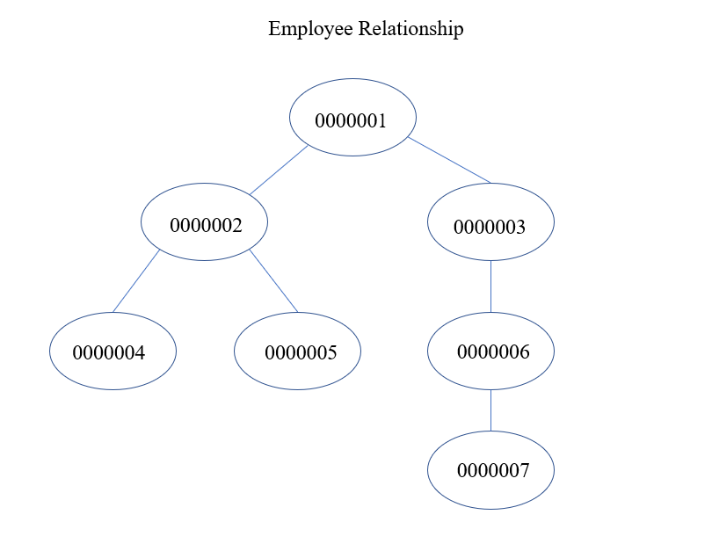

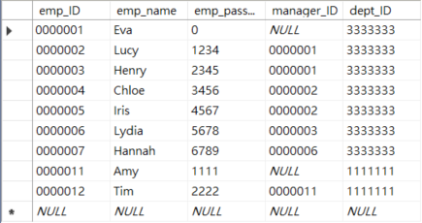

The data of employees is already implemented in the database. The above picture is the relationship of all employees.

**The login page**: Enter your ID and password, then click the login button.

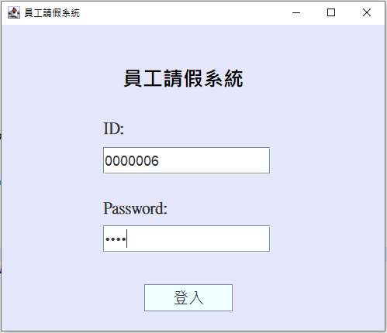

**Notification:** After you log in, the number of approvals that haven’t been approved will be shown.

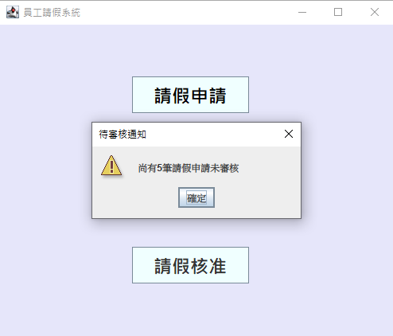

**The option page**: There are three functions to select.

You can click the one you would like to run.

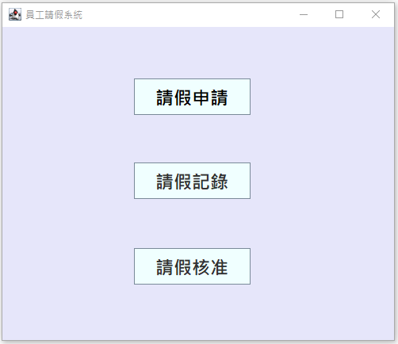

**Leave application page:** Fill in the application form.

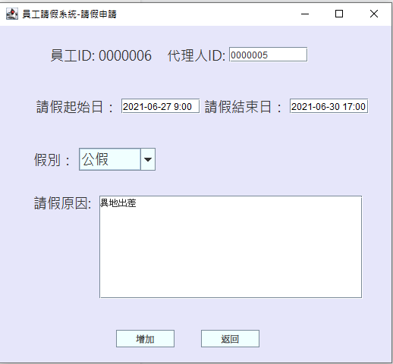

**Leave application page:** If you fill in all the blanks correctly, the application will be stored in the database successfully. In addition, type a space and insert the time after the date.

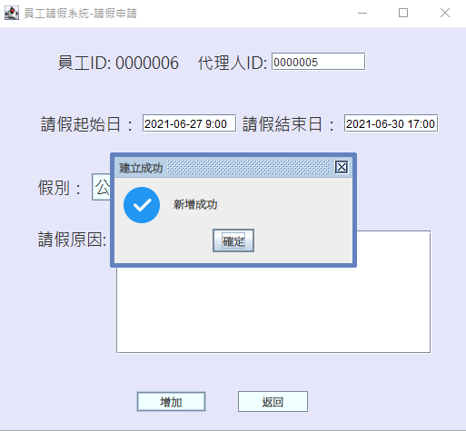

**Leave application page:** If you don’t fill in all the blanks or you fill in the wrong ID, the application will fail.

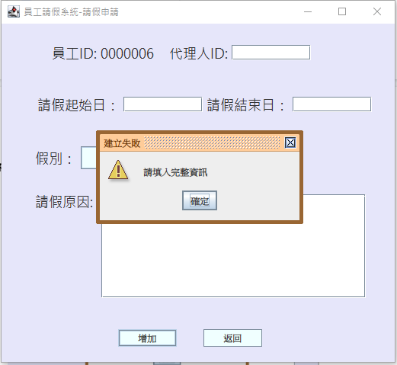

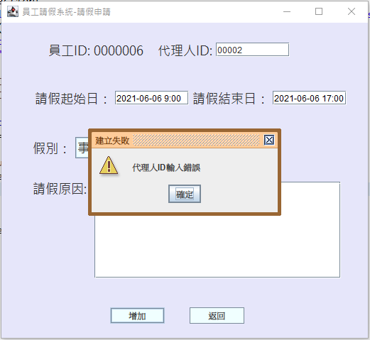

**Leave record page:** Select the date interval and click the search button, you can see your leave records, the corresponding approval status and results.

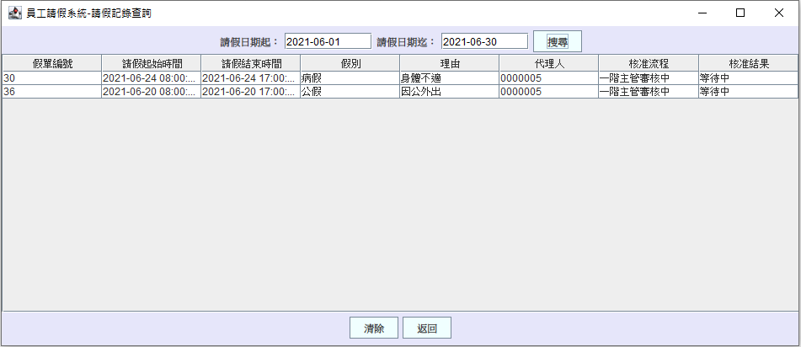

If you want to view the detail of the application, you just click on that row and the detail frame will be shown.

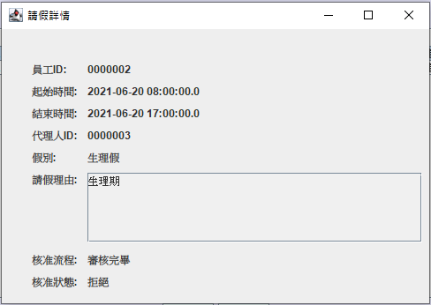

**Leave approval page:** If you are a manager, you can see the leave application awaiting your approval.

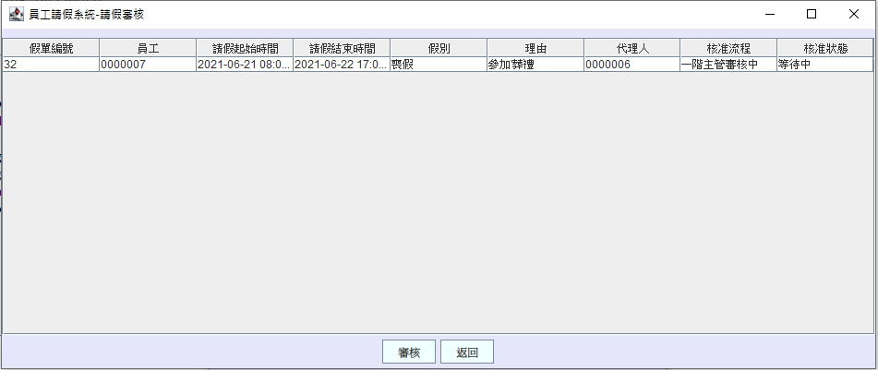

Same as the leave record page, if you want to view the detail, click on the row and the detail frame will be shown.

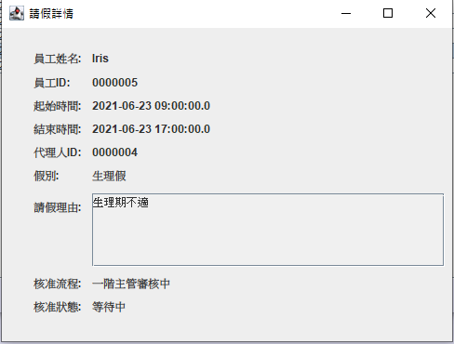

**Hypothetical situations**

Case1

**Manager view:** During the approval status, if the permission level is two(leaveType: maternity leave) and the first-level manager approves the leave application with leave ID 39.

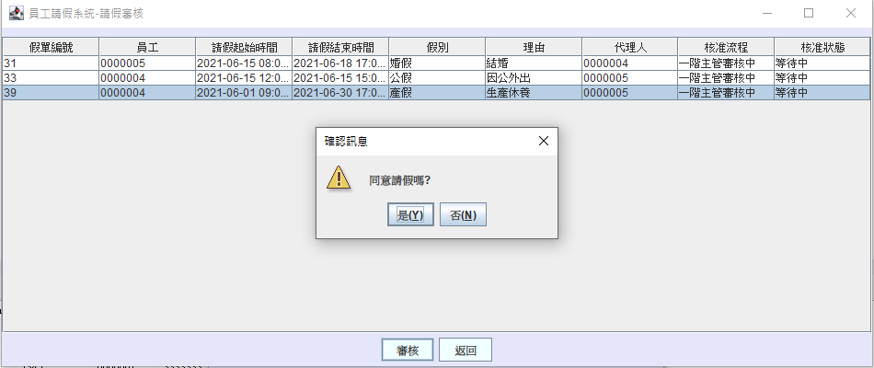

**Employee view:**  The employee can see the approved status showing that the application is "awaiting the second-level manager’s approval".

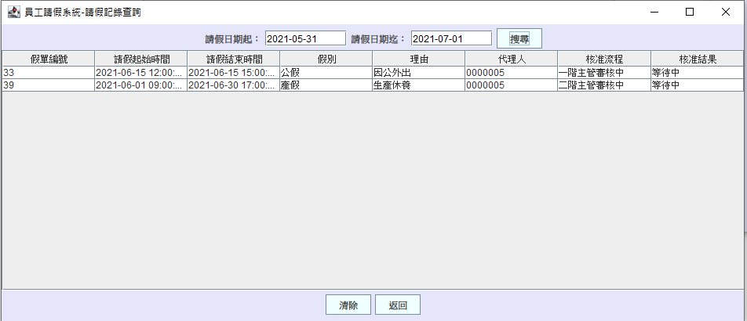

**Manager view:** Next, the second-level manager also agrees with the application.

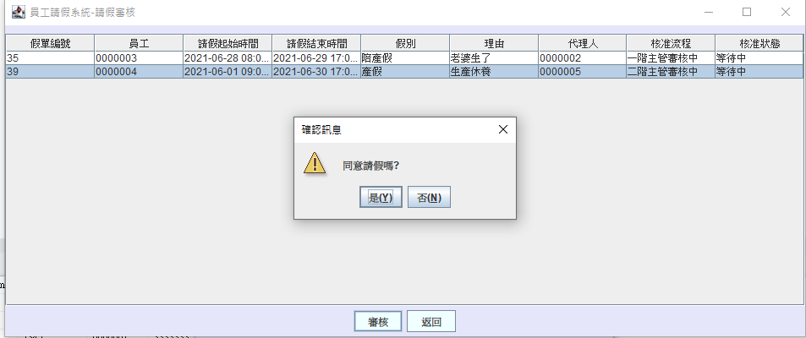

**Employee view:** The employee will see the approval results which shows “accept” in the leave record page.

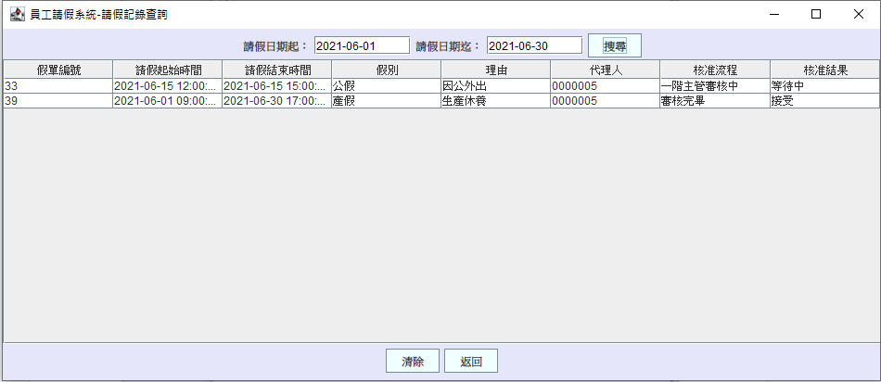

Case 2

**Manager view:** If the permission level is 2(leaveType: marriage leave), and the application with leave ID 31 is rejected by the first-level manager.

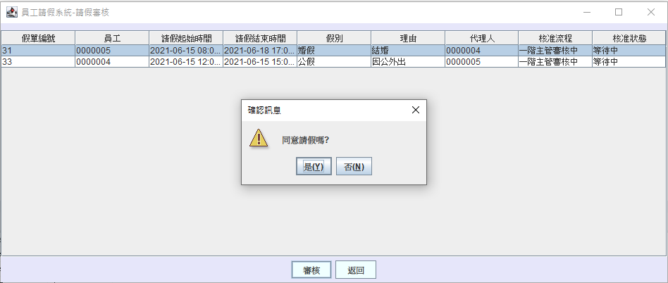

**Employee view:** The employee will see the approval result which shows “reject” in the leave record page.

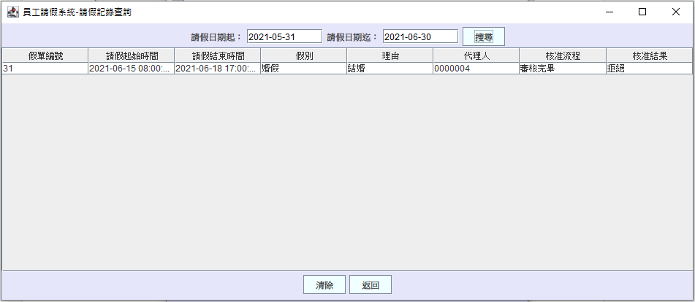

Case 3

**Manager view:** If the permission level is two(leaveType: bereavement leave) and the first-level manager approves the leave application with leave ID 41.

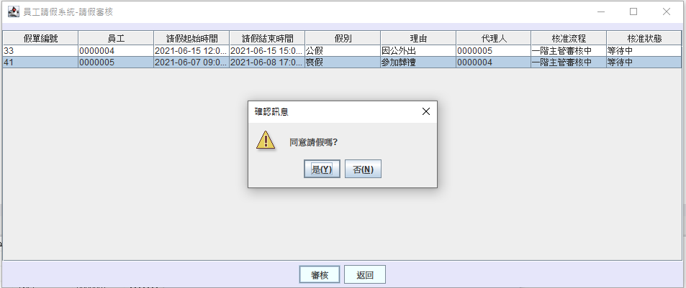

**Employee view:** The employee will see the approval status which shows”awaiting the approval of the second-level manager” in the leave record page.

**Manager view:** However, the second-level manager disagrees with the application.

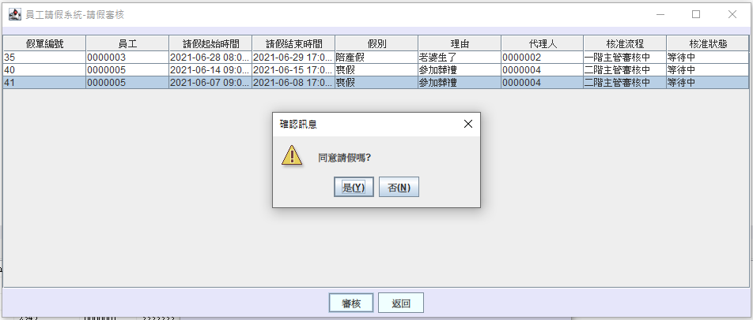

**Employee view:** The employee will see the approval result which shows “reject” in the leave record page.

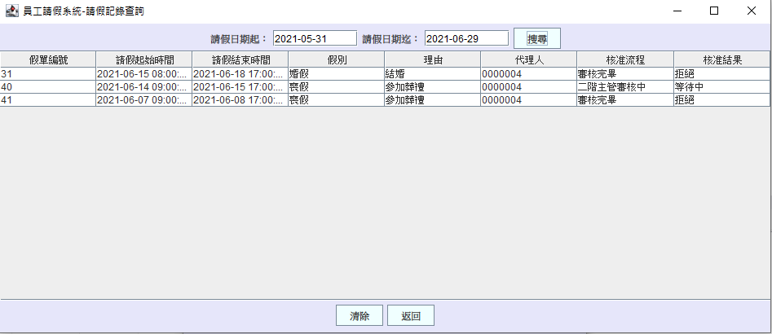

Case 4

If the permission level is 2, but the employee only has one manager, then the application will directly be approved after the manager permits it.

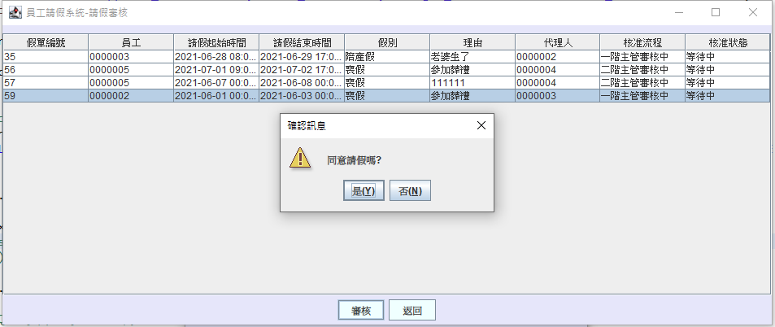

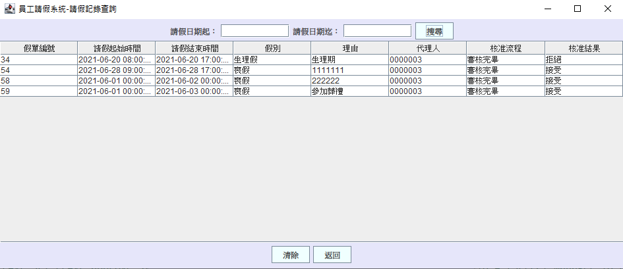

**Database in SQL Server**

**Department Table: Consists of dept_ID(PK), dept_name**

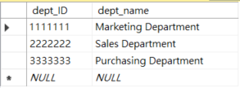

**LeaveType Table: Consists of leaveType_ID(PK), leaveType_name, permission_level**

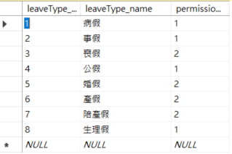

**Employee Table: Consists of emp_ID(PK), emp_name, manager_ID(FK), dept_ID(FK)**



**Leave Table: Consists of leave_ID(PK), start_date_time, end_date_time, leave_reason, approve_status, permissiion_level(FK), leaveType_ID(FK), emp_ID(FK), manager_ID(FK), agent_ID(FK)**

